Aging & Your Cat
Why Six Month Wellness Exams Make Sense

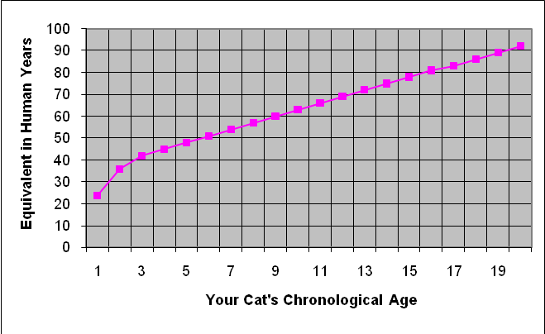
Did you know that by age one, a cat
has already aged the equivalent of
24 human years? By the time they
are 4, a cat is already the equivalent
of 45 in human years! So when it
comes to their health care, a visit to
their veterinarian should be more
than once a year.

Because cats age so rapidly, major
health changes can occur in as little
as three months. The risk of cancer,
diabetes, hyperthyroidism, obesity,
arthritis and heart disease all
increase with age. Many cats
are also living longer, thanks to better care and an increasingly indoor-only lifestyle. Therefore, the likelihood your cat will experience some form of age-related illness is greater.

Twice-a-year wellness exams provide our veterinarians with the opportunity to prevent problems before they become too advanced and more difficult to control. Sometimes disease processes may even be detected and treatment started before any physical symptoms arise! The goals of twice-yearly wellness exams are to prevent or minimize disease or injury and enhance the quality of your cat's life.

Twice-yearly examinations do not necessarily mean that your cat is going to be subjected to a barrage of complicated or costly medical tests and treatments. While some cats may warrant the close monitoring of blood work, x-rays or other tests, many cats benefit simply from being physically examined, having their heart and lungs listened to and their general health reviewed every six-months. A dental health exam and a weight check are always important parts of a wellness exam, as both conditions may develop problems that can progress rapidly and can have significant impact on your cat's overall health.

Twice-yearly wellness exams benefit your cat and you as well. It means an increased opportunity to individually discuss those issues that are of greatest concern to you and for us to share new information as it pertains to your cat's health. Our client relations specialists (CRS), technicians and doctors are all here to provide the very best care for both you and your cat. Of course, we are always available during office hours by (973)-228-4444 After-hours our voicemail system is available for you to leave a message.

